**CODING ASSESMENT SQL Vinutha s**

**13/12/2023**

1. **Querying Data by Using Joins and Subqueries**

**Ex-1 Inner join**

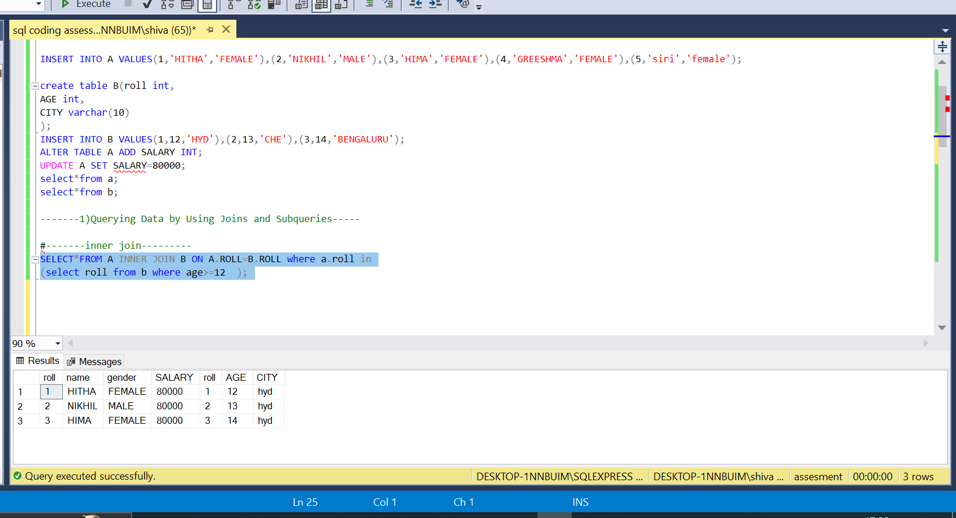

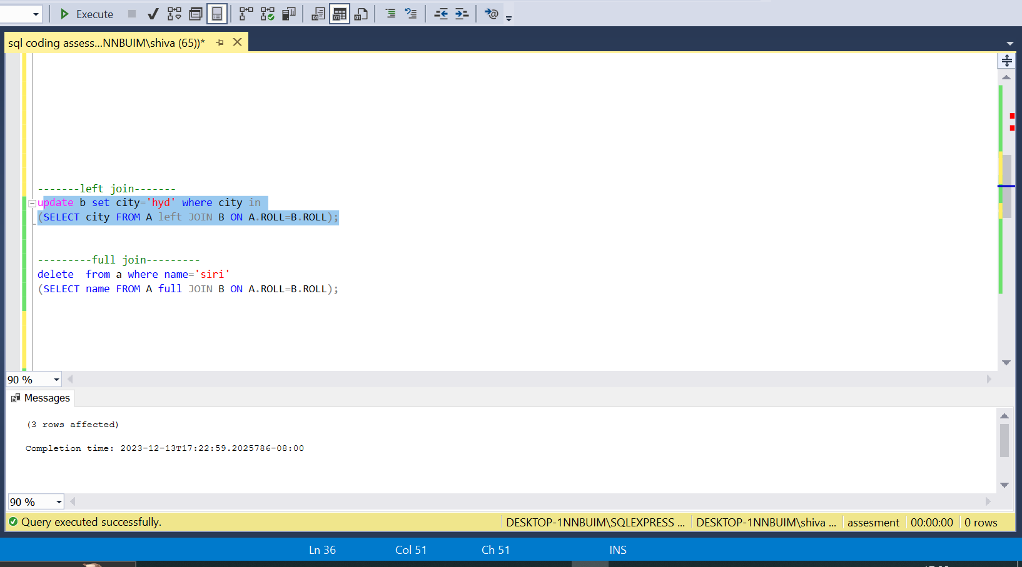**Ex-2 left join**

**Ex-3 right join**

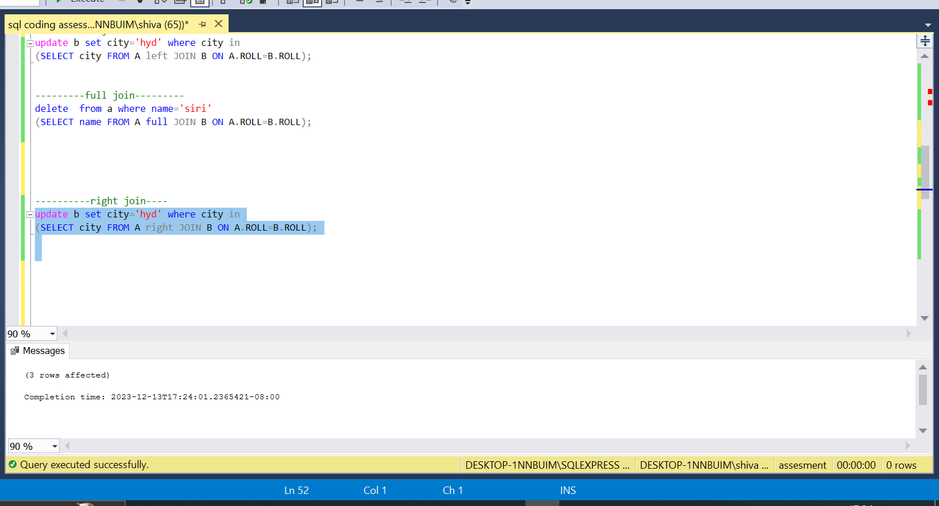

1. **Manipulate data by using sql commands using group by and having clause**.

**Group by clause**

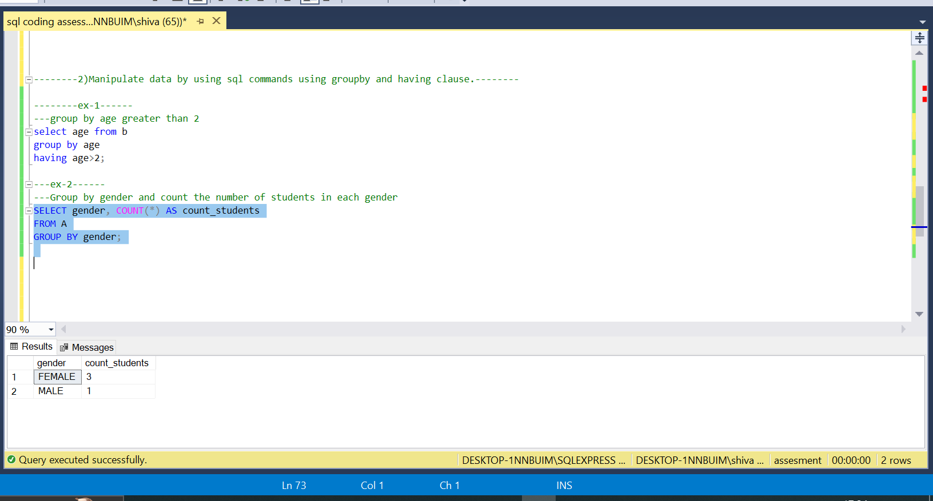

**Having clause**

